

**GROUP ASSIGNMENT**

**TECHNOLOGY PARK MALAYSIA**

**CT043-3-1-IN-L-7**

**INTRODUCTION TO NETWORKING**

**APD1F2109CS(CYB)**

**HAND OUT DATE : 11TH OCTOBER 2021**

**HAND IN DATE : 24th DECEMBER 2021**

|  |  |
| --- | --- |
| **Student Name** | **TP Number** |
| ABDULLAH ABSHIR ABDULLAHI | TP066766 |
| AKBAROV AMIRJON AKHMALOVICH | TP060483 |
| NIYOZOV FERUZ NODIR UGLI | TP061846 |
| ABDELRAHMAN MOURAD ABDELSATTAR RAMADAN | TP064361 |

**Introduction**

**Company Description**

In this assignment, the company Seagate.co is being discussed, and is a company that mainly manufactures storage devices for computers such as hard drives, solid state drives, and other devices. Seagate has many branches located around the world, some in North America, Europe and Asia. The company has seen rapid growth in demand and sales in the past decade, especially in south east Asia, and is planning to expand its business. Seagate.co executives have announced the development of a new branch in Cyberjaya by 2023, and plans are made to update the network infrastructure from the Penang branch to make new network infrastructure making it better and more efficient with employees of the company. Cyberjaya and Penang buildings both have 2 floors and network in each floor of both buildings are configured accordingly.

**Assignment Objective**

Seagate’s new branch in Cyberjaya will be modified to meet the requirements of executives by its opening in 2023. As a result, new network infrastructure must be designed and configured to function as best as possible. Buildings are to be made or modified as planned, with the first floor of both buildings mainly having reception area, waiting room, CEO room, CTO room, Cafeteria, Administrative office, Finance and Sales, and Security and Delivery departments. As for the second floor, both buildings will have an R&D room, manufacturing, server room, technical assistant department for network monitoring, staff rest area, and two conference rooms. Other than that, departments of both buildings will be equipped standard with IoT devices like air conditioners and CCTV. For network infrastructure design, buildings are first configured to be able to communicate and send data to and from both floors digitally, and to also solve any connection issues inside the building. After that, the new network configuration of both branches will be connected to be able to send and receive data efficiently and with minimal issues in the network. Cisco packet tracer is used to configure the devices and sort them in a method that they can communicate without issues in the network.

**Assumptions**

For this assignment, there will be some assumptions for the topology types used and how whether it is best for the network infrastructure. In addition, the number of hosts for each room and floor will also be implemented including network configuration. These factors are important to use during the assignment and work.

**Penang**

The Penang branch will have some redesigns to its network infrastructure to improve existing systems and connections. Some devices and areas will require upgrades to get it to the same level as the ones in the new Cyberjaya building which most likely has newer and more modern devices and facilities available. Things such as CCTV, AC and computers in Penang branch should be updated to better and more efficient models of those devices to improve company function.

**Cyberjaya**

This is the new branch for Seagate, and is their top concern as new network infrastructure and building design must be up to date and improve on the previous designs. Doing so will help Seagate attract more customers and investors into their company and allow them to further expand their branches and manufacturing, and also introduce new innovations into their network. The network design is prioritized in order for the branch to communicate with other branches and function as efficient as possible.

**Summary**

Summarizing the introduction and assumptions of both branches, the new Seagate branch in Cyberjaya has shared building design with Penang. Both buildings are to have eight departments in the first floor and seven departments on the second floor. On the other hand, new network infrastructure must be designed for Cyberjaya building and the one in Penang must be updated to make it better and easier to work with. IP addressing should also be done in a way which will allow both building to share data easily with one another and improving the system as much as possible. Topology and network configuration will have further justification to explain the plan accurately and in a clear manner.

**Group Assignment**

**Network Topology**

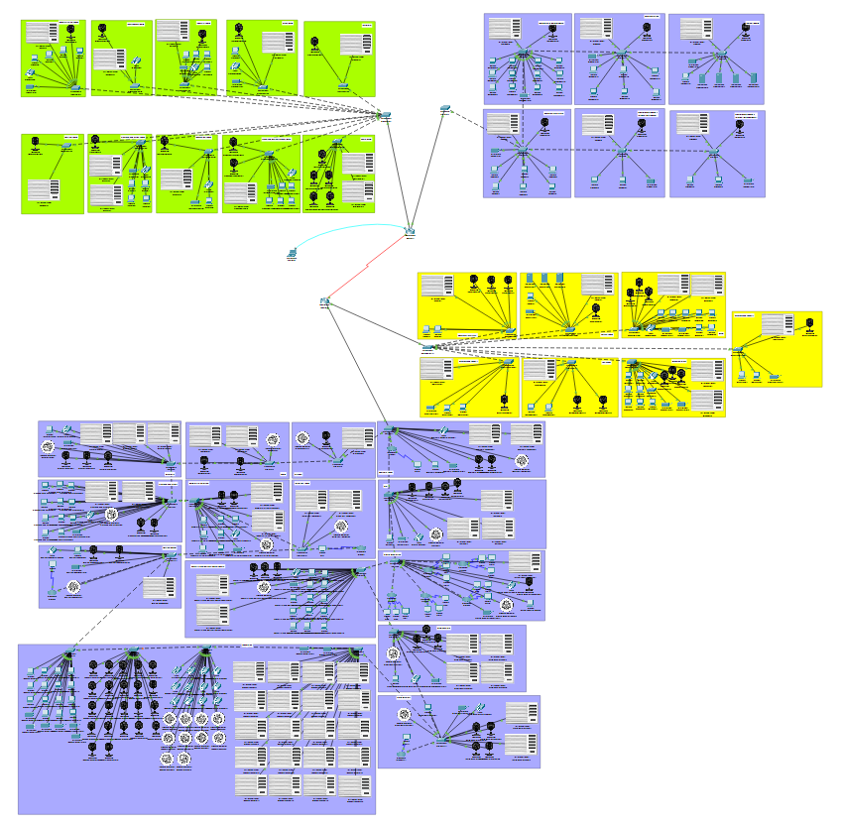

In the diagram above, the upper part of the topology is the Cyberjaya building, and the bottom part is the Penang building. The right part of both buildings are the second floor of each, and the left part of both buildings are the first floor of each, showing clearly the topology design of all floors of both buildings.

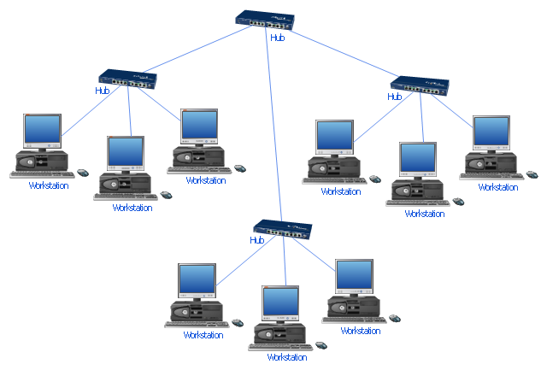

This is the topology that was used in the assignment, the Extended Star Topology, to connect all end devices on the network. This topology is a one of the variants of the star topology, in which the hub connecting end devices of a small network is connected to a central device - which is the router in this case – to manage the entire network and connections. This topology is best suited for companies as they have a large number of devices in the organization, and needs to be managed efficiently in order for the network to function properly, so a central network will be helpful in sharing data and information in the entire building.

Configuration of Router

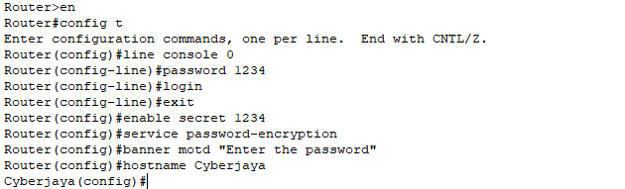

Diagram (1.1)

Diagram (1.1) shows the router of Cyberjaya. This router has been providing a hostname which is Cyberjaya and unique password. The password of the user execution mode is 1234, and privileged execution mode is 1234 to ensure only the administrator can make change to the router. Banned is including in the configuration to display a message for the user that log in to the router.

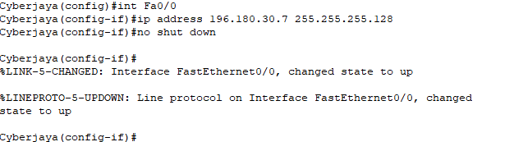

Diagram (1.2)

The IP address 196.180.30.7 and the subnet mask 255.255.255.128 is the assigned for the gateway touter at the interface of Fa0/0 in Cyberjaya building as shown as diagram (1.1).

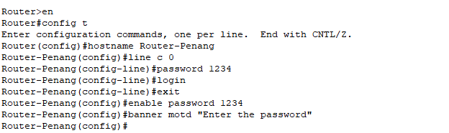

Diagram (1.3)

Diagram (1.3) show the configuration of the router in Penang. This router is given a hostname which is Router-Penang. The password of the user execution mode is 1234, and privileged execution mode is 1234, and it is only known by the administrator to make change to the router. A banned is added to display a message if user log in in to the router. For router-Penang also need to add the IP address and subnet mask.



Diagram (1.4)

In diagram (1.4) , the IP route of network ID in Penang is configured to the router of Cyberjaya building. The first network ID is the floor of Cyberjaya which is 196.180.30.128 and the network ID of the second floor of Penang is 196.180.30.0. Subnet mask of these network ID is 255.255.255.128.